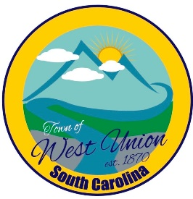
West Union Town Council
Tuesday, February 13, 2024 @ 5:30 pm
West Union Town Hall

Call to Order
Certify Quorum
Invocation
Pledge of Allegiance
Public Comments
Council Comments
Minutes
Reports from committees
Police-
Fire-
Roads/Streets-
Maint. /Water-
Events-
Old Business:
New Business:
- MASC representative Namoi Reed, Q&A regarding zoning
- First reading of annexing Norfolk Southern Railroad Property from the Town Limit of West Union to Winston Way
- First reading of Article 18 Chapter 26 – Open Container
- First reading of Article 18 Chapter 27 – Operating a Drug House, Business
- First reading of Article 18 Chapter 28 – Loitering and Prowling in Town Limits
- Discussion and possible vote on creating a policy and form on requests for expenditures
- Discussion and vote on drinking water sampling company
- First reading of 2024-2025 Annual Budget
Attorney Update
Adjourn

