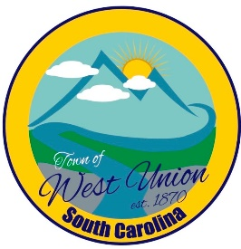
West Union Town Council
Tuesday, April 09, 2024
5:30pm

Call to Order
Certify Quorum
Invocation
Pledge of Allegiance
Public Comments
Council Comments
Minutes
Reports from committees
Police-
Fire-
Roads/Streets-
Maint. /Water-
Events-
Old Business:
New Business:
- Discussion and vote on CD renewal notice
- Discussion and possible vote on garbage collection
- Discussion on West Union Town Park
Attorney Update
Adjourn

