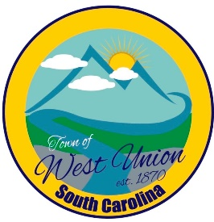
West Union Town Council
Tuesday, May 12, 2026 @ 5:30 pm
1438 W Main St
West Union Station
Agenda

Call to Order
Invocation
Minutes
Public Comments
Council Comments
Attorney Comments
Reports from Committees
- Police
- Fire
- Maint./Water
- Roads/Streets
- Events
Old Business:
New Business:
- Discussion and vote on installing additional cameras at the Maintenance Building
- Discussion and vote on making amendment to yearly budget to allow the hiring of a part time administrative assistant
- Set a date for Employee Handbook Workshop
- Discussion and possible vote on email from realtor concerning Main Street property
Adjourn

