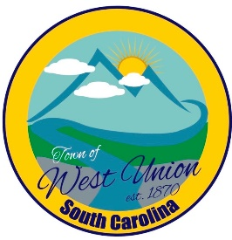
West Union Town Council
Friday, August 22, 2025 @ 4:30 pm
1438 W Main St
West Union Station
Special Meeting

Call to Order
Certify Quorum
Executive Session - the purpose of discussing negotiations incident to potential contractual arrangements regarding a sale and/or a purchase of real property and the receipt of legal advice regarding same.
Adjourn

