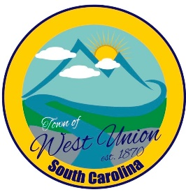
West Union Town Council
Tuesday, April 14, 2026 @ 5:30 pm
1438 W Main St
West Union Station

Call to Order
Invocation
Pledge of Allegiance
Minutes
Public Comments
Council Comments
Attorney Comments
Reports from Committees
Police
Fire
Maint./Water
Roads/Streets
Events
Old Business:
New Business:
Adjourn

