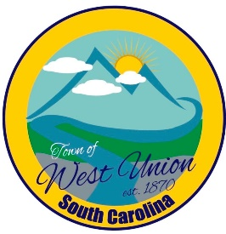
West Union Town Council
Tuesday, August 11, 2026 @ 5:30 pm
Public Hearing @ 5:15pm for Millage Rate
1438 W Main St
West Union Station
Agenda
Call to Order
Certify Quorum
Invocation
Pledge of Allegiance
Minutes
- Approval of Minutes for July 14, 2026
- Approval of Minutes for July 29, 2026
Public Comments concerning the Penny Sales Tax
Public Comments
Attorney Comments
Reports from Committees
Police
Fire
Maint./Water
Roads/Streets
Events
Beautification
Old Business:
- Second reading on increasing millage rate
- Second reading on annexing parcel # 192-00-02-030
- Second reading on Penny Tax referendum
New Business:
- Discuss volunteer dates for the Salvation Army
Executive Session: To discuss personnel matters (Note: Upon returning to open session, council may take action on matters discussed in executive session.)

Adjourn

