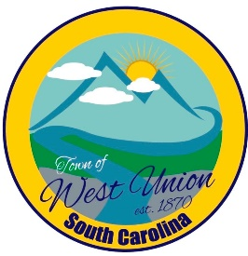
West Union Town Council
Tuesday, August 18, 2026 @ 11:00 AM
1438 W Main St
West Union Station
Special Called Meeting

Call to Order
Certify Quorum
- Second reading on increasing millage rate
Adjourn

