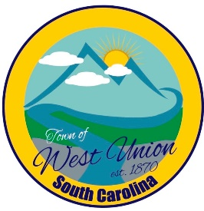
West Union Town Council
Tuesday, July 14, 2026 @ 5:30 pm
1438 W Main St
West Union Station
Agenda

Call to Order
Certify Quorum
Invocation
Pledge of Allegiance
Minutes
- Approval of Minutes for June 9, 2026
- Approval of Minutes for June 30, 2026
Public Comments
Attorney Comments
Reports from Committees
Police
Fire
Maint./Water
Roads/Streets
Events
Beautification
Old Business:
- Discussion and vote on Millage Rate
- First reading on annexing parcel # 192-00-02-030
- First reading on annexing parcel # 192-00-02-049
- First reading on annexing parcel # 192-00-02-039
New Business:
- Discussion and vote on Sewer Rates
- Discussion on a referendum for a penny tax
Executive Session: Pursuant to SC Code Sec. 30-4-70(a)(1), for the purpose of discussing past and future compensation of employees in the form of compensatory time and other forms of paid or unpaid time off.
- Council may or may not act on the matters discussed in executive session upon returning to regular session
Adjourn

