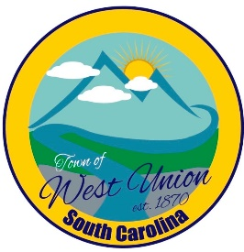
West Union Town Council
Tuesday, January 9, 2024 @ 5:30 pm
West Union Town Hall

Call to Order
Certify Quorum
Invocation
Pledge of Allegiance
Public Comments
Minutes
Reports from committees
Police-
Fire-
Roads/Streets-
Maint. /Water-
Events-
Old Business:
- Second reading of Article 18 Chapter 25- Obstruction of Law Enforcement, Firefighters and EMS
New Business:
- Discussion and possible vote on sewer for Phase II plans for Habitat
- Discussion and vote on financial help with water leak at Marathon Gas Station
Attorney Update
Executive session pursuant to S.C. Code Section 30-4-70(a)(2) for the purpose of discussions related to contract negotiations and the receipt of legal advice. This matter concerns discussion of the potential sale, lease, and/or purchase of real property within the Town limits.
Adjourn

