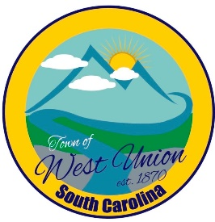
West Union Town Council
Tuesday, November 14, 2023 @ 5:30 pm
West Union Town Hall

Call to Order
Certify Quorum
Invocation
Pledge of Allegiance
Swearing In Ceremony by Judge Will Derrick
Public Comments
Minutes
Reports from committees
Police-
Fire-
Roads/Streets-
Maint. /Water-
Events-
Old Business:
New Business:
- First reading of Business Licenses Ordinance
- Assign Departments
- Appointment of Mayor Pro Temp
Attorney Update
Adjourn

