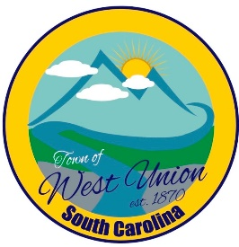
West Union Town Council
Tuesday, September 12, 2023 @ 5:30 pm
West Union Town Hall

Public Hearing will be held at 5:30pm to discuss Mayor and Council annual compensation increase
Call to Order
Certify Quorum
Invocation
Pledge of Allegiance
Public Comments
Minutes
Reports from committees
Police - Chief Jeff Richardson
Fire – Councilman Doug Moore
Roads/Streets – Councilman Boyd Nicholson
Maint. / Water – Councilwoman Dixie Meeks
Beautification – Councilwoman Carol Mendoza
Events – Mayor Linda Oliver
Old Business:
- Second reading of Article 2 Chapter 2 – Municipal Council
- Second reading of setting compensation for Mayor and Council
New Business:
- First reading of Article 18 Chapter 24- Yard Sales
- First reading on increasing Business Licenses Fees
- Discussion and vote on Water Purchase Agreement Form
Attorney Update
Executive Session: To discuss personnel matters (Note: Upon returning to open session, council may take action on matters discussed in executive session.)
Adjourn

