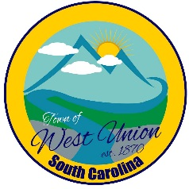
West Union Town Council
Tuesday, August 8, 2023 @ 5:30pm
West Union Town Hall

Call to Order
Certify Quorum
Invocation - Chaplain
Pledge of Allegiance
Public Comments
Minutes
Reports from committees
- Police
- Fire
- Roads/ Streets
- Maint./ Water
- Beautification
- Events
Old Business
- Second Reading Article 18 Chapter 5 Unsanitary, Unsightly, & Unsafe Conditions
- Second Reading Article 18 Chapter 6 Conditions Affording Food or Harborage for Rats
- Second Reading Article 18 Chapter 7 Burning of Trash, Household Items and other Property
- Second Reading Article 18 Chapter 8 Junk Vehicles
- Second Reading Article 18 Chapter 21 Blanket Trespass Warning Authorization Program
- Second Reading Article 18 Chapter 22 Trespass After Warning
- Second Reading Article 18 Chapter 23 Camping on Private or Public Property in Town Limits
New Business
- Discussion and possible vote on #13 Overtime and Comp time in Employee Handbook
- Discussion and possible vote on hours worked
Attorney Update
Adjourn

