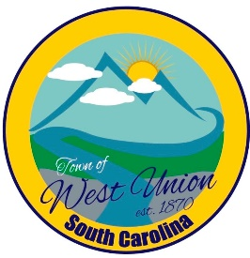
West Union Town Council
Wednesday, July 29, 2026 @ 5:30 pm
1438 W Main St
West Union Station
Agenda

Call to Order
Certify Quorum
- Robert Wolfe with MASC will discuss the new penny sales tax and answer questions
- Council will possibly vote whether to place the new penny sales tax on the referendum for November election
Adjourn

