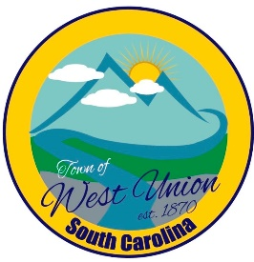
West Union Town Council
Tuesday, October 10, 2023 @ 5:30 pm
West Union Town Hall

Call to Order
Certify Quorum
Invocation
Pledge of Allegiance
Public Comments
Minutes
Reports from committees
Police- Chief Jeff Richardson
Fire- Doug Moore
Roads/Streets- Boyd Nicholson
Maint. /Water- Dixie Meeks
Events-Mayor Linda Oliver
Old Business:
- Second reading of Business Licenses Rate Increase
- Second reading of Article 18 Chapter 24 – Yard Sale
- Second reading of McDonalds Corporation annexation
- Second reading of Advance Auto annexation
- Second reading of Holcombs Office Supply, Quality VIP annexation
New Business:
- Resolution declaring October 2023 Disability Employment Awareness Month
Attorney Update
Executive Session Pursuant to S.C. Code Sec. 30-4-70(a)(1) - Discussion of employment, appointment, compensation, promotion, demotion, discipline, or release of an employee, and the receipt of legal advice regarding same. After returning to Regular Session, Council may take action on the matters discussed in Executive Session
Adjourn

